Launch one ec2 instance using amazon linux 2.

Install Docker

Install jenkins

Install apache

Install nginx

Install Apache Tomcat

**Created EC2 instance and in security group enable ports.**

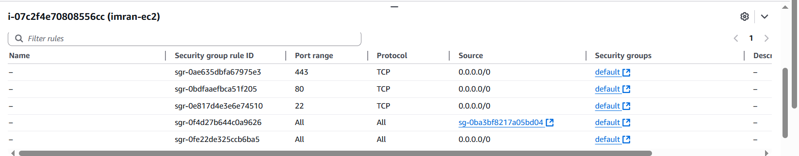

**1.Install Docker**

1. **sudo yum install -y docker**
2. **sudo systemctl start docker**
3. **sudo systemctl enable docker**
4. **sudo usermod -aG docker ec2-user # so you can run docker without sudo**
5. **docker --version**
6. 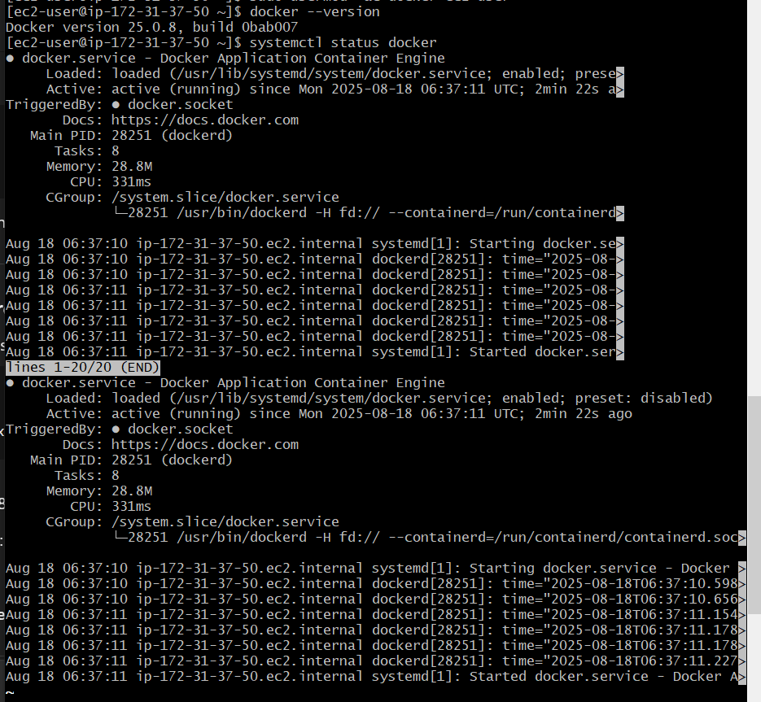

**2.Install jenkins**

1. **Install java 17, its a pre requisite for jenkins**
2. **sudo dnf install java-17-amazon-corretto -y**
3. **Java -version**
4. 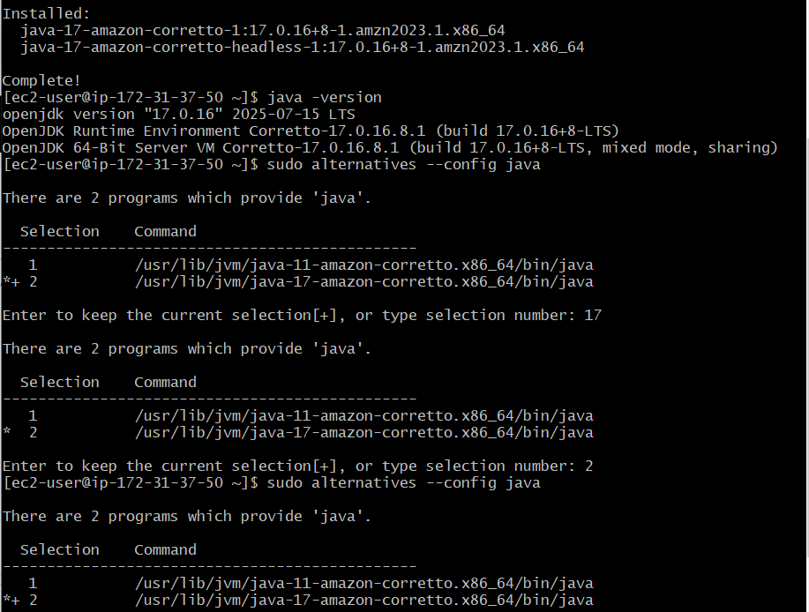
5. **Now install jenkins**
6. **sudo wget -O /etc/yum.repos.d/jenkins.repo \**

**https://pkg.jenkins.io/redhat-stable/jenkins.repo**

1. **sudo rpm --import https://pkg.jenkins.io/redhat-stable/jenkins.io-2023.key**
2. **sudo dnf install jenkins -y**
3. **sudo systemctl enable jenkins**
4. **sudo systemctl start jenkins**
5. **sudo systemctl status jenkins**
6. 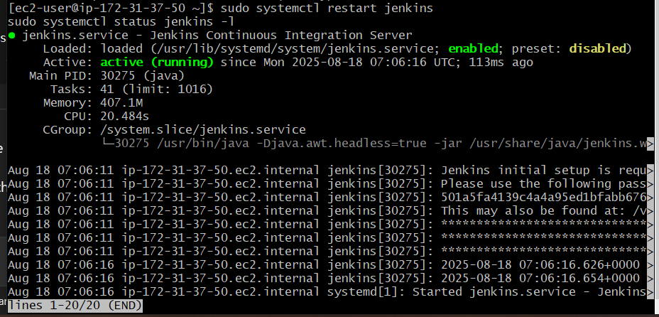
7. **Now check in browser**
8. **http://18.209.177.34:8080/login?from=%2F**
9. 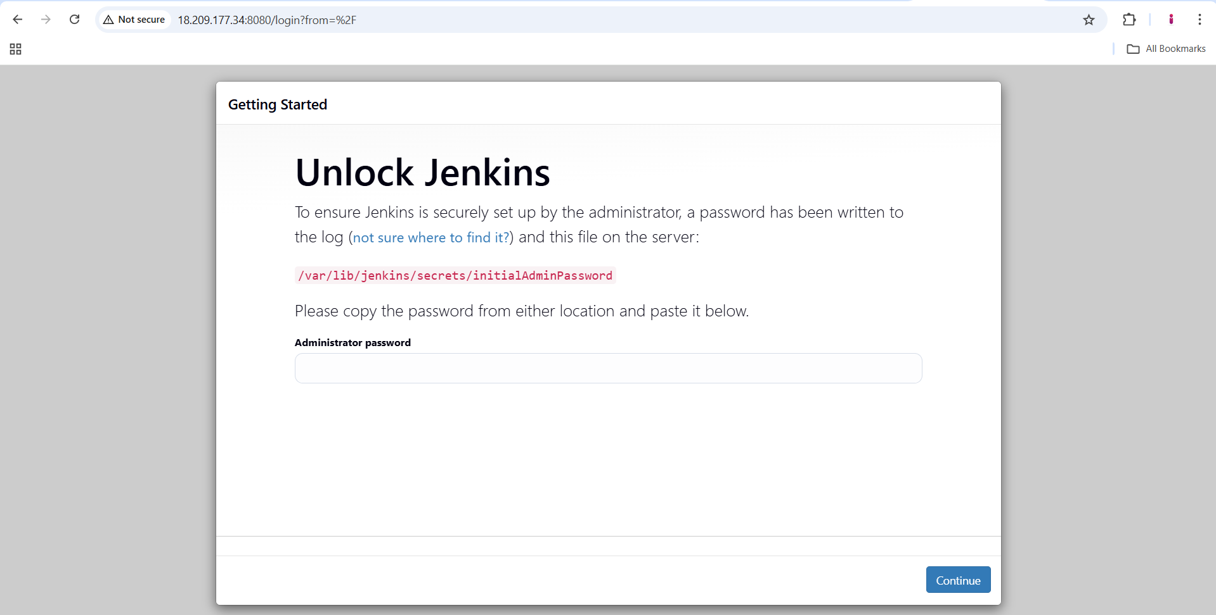
10. 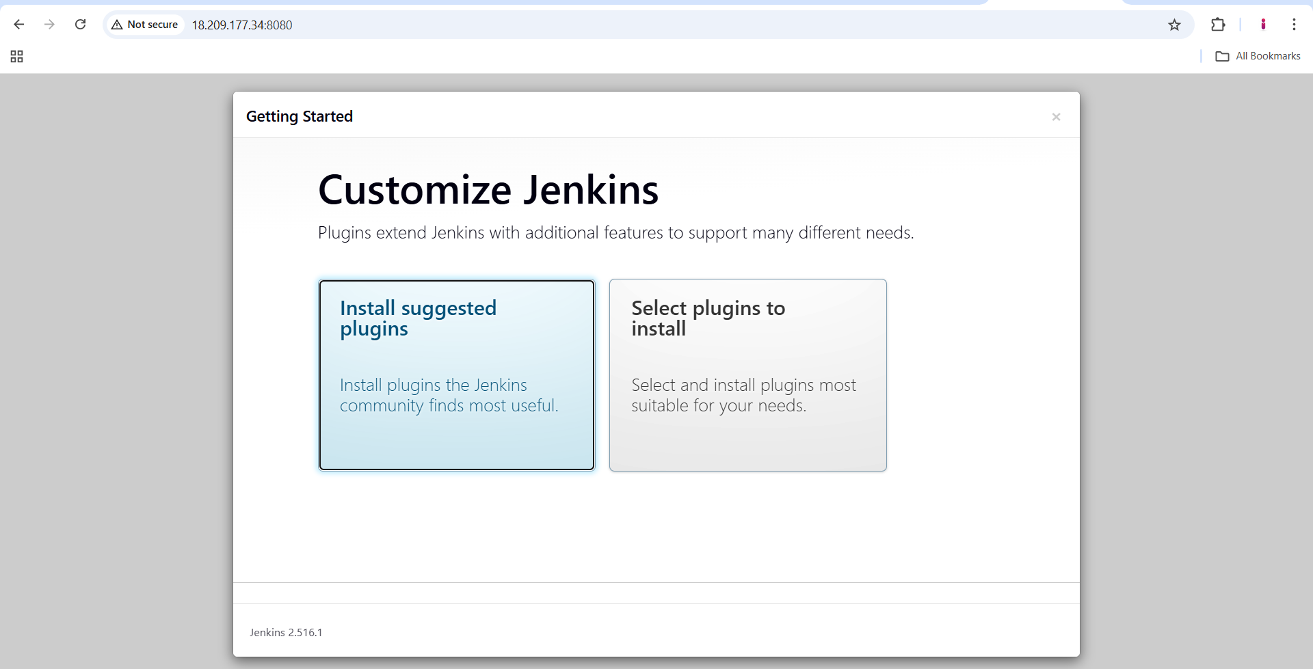
11. **After installation create user with email details**
12. 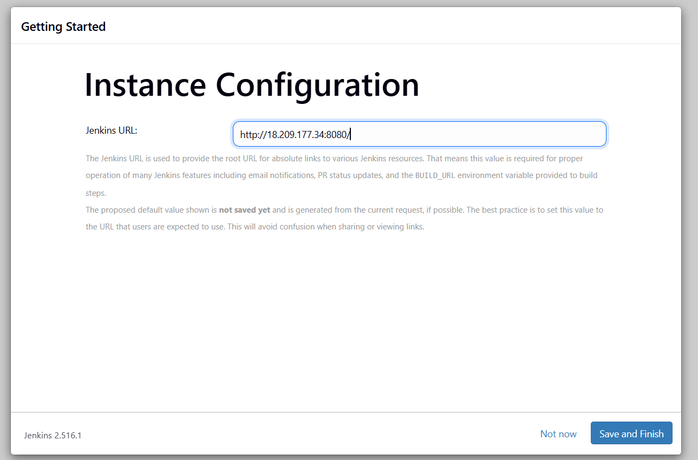
13. **http://18.209.177.34:8080/**
14. 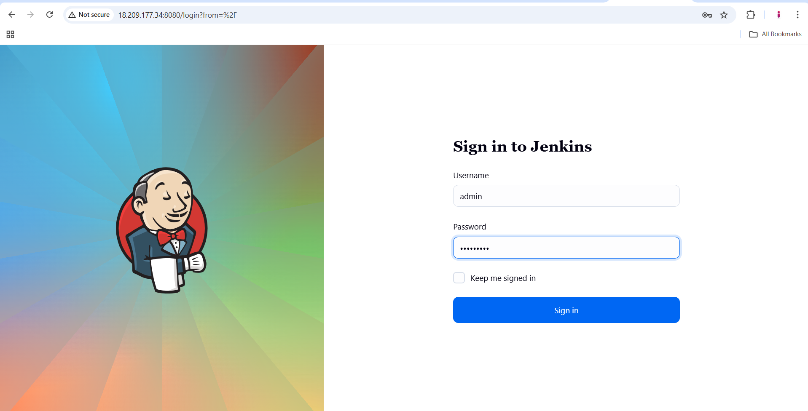
15. 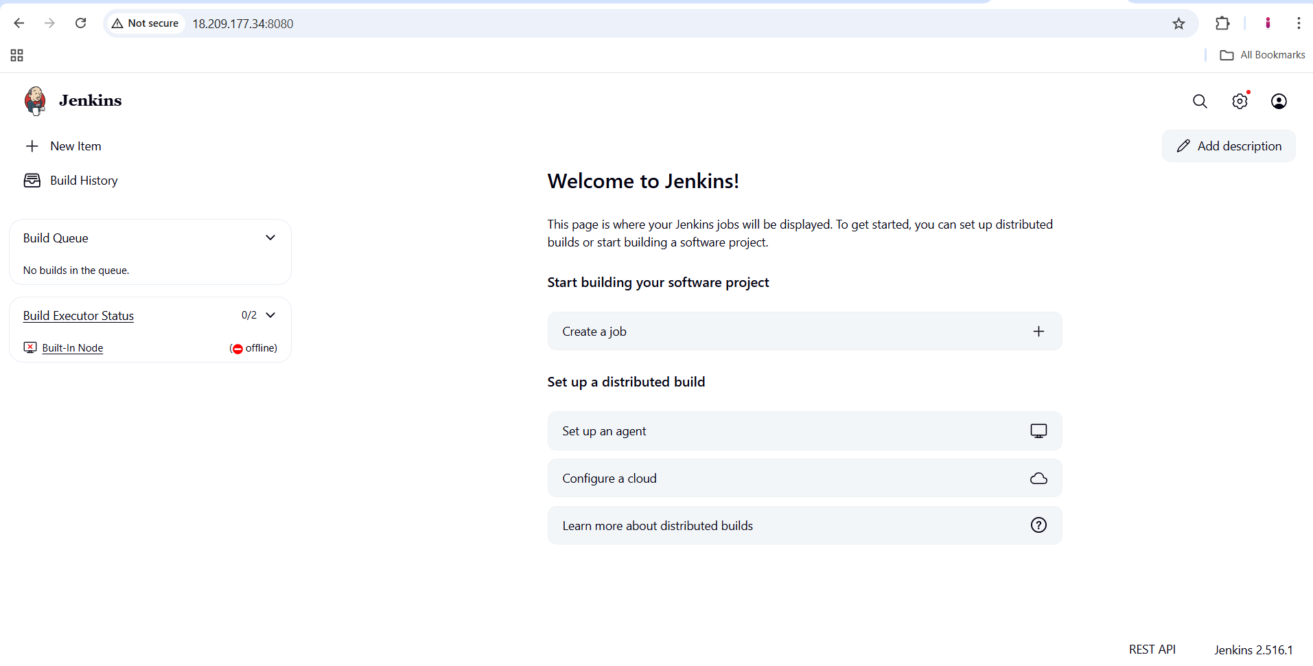

**3.Install apache**

1. **sudo yum install -y httpd**
2. **sudo systemctl start httpd**
3. **sudo systemctl enable httpd**
4. 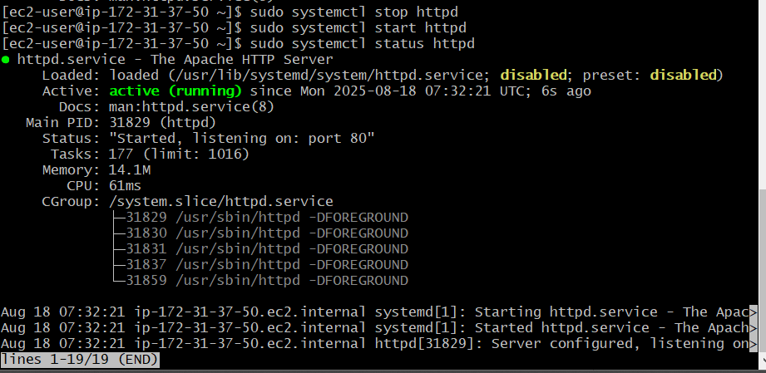
5. **http://18.209.177.34/**
6. 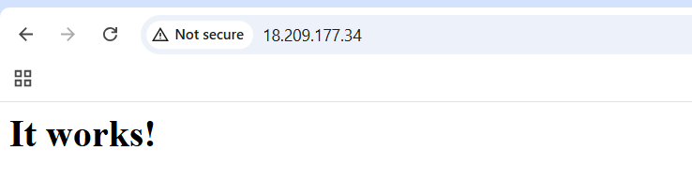

**4.Install nginx**

1. **sudo yum install -y nginx**
2. **sudo systemctl start nginx**
3. **sudo systemctl enable nginx**
4. 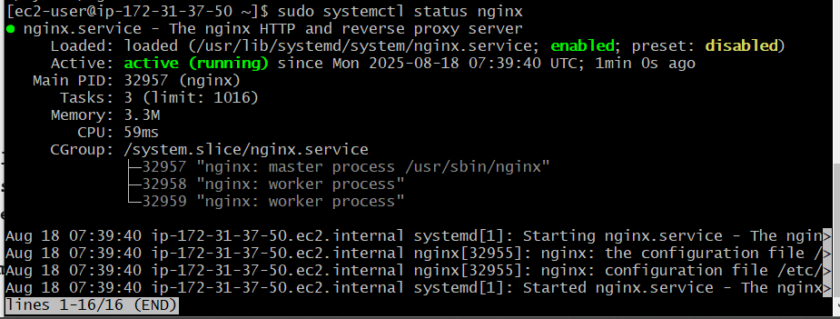
5. **sudo systemctl status nginx**
6. 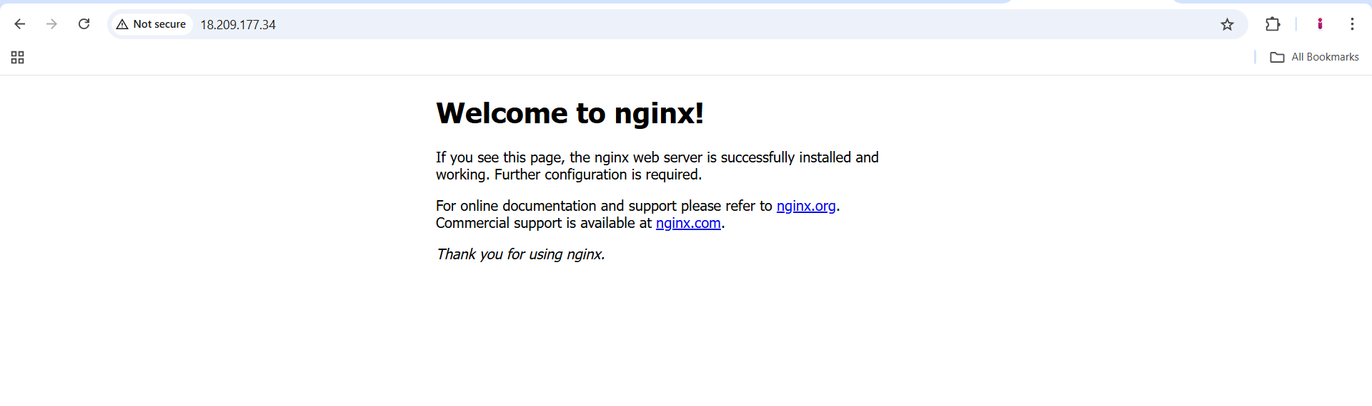

**5.Install Apache Tomcat**

1. **sudo yum install -y wget tar**
2. **Wget** [**https://dlcdn.apache.org/tomcat/tomcat-9/v9.0.108/bin/apache-tomcat-9.0.108.tar.gz**](https://dlcdn.apache.org/tomcat/tomcat-9/v9.0.108/bin/apache-tomcat-9.0.108.tar.gz)
3. **tar xvf** [**apache-tomcat-9.0.108.tar.gz**](http://apache-tomcat-9.0.108.tar.gz)
4. **sudo mv apache-tomcat-9.0.108 /opt/tomcat**
5. **sh /opt/tomcat/bin/**[**startup.sh**](http://startup.sh)
6. 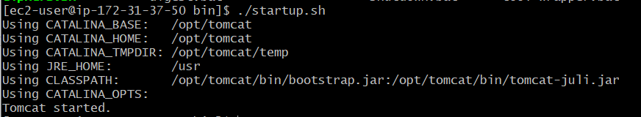
7. 